Exp 8. Create a Virtual Hard Disk and allocate the storage using virtual box.

Step 1: Open the virtual box and select the Existing OSI file and click on the top yellow icon which is settings.

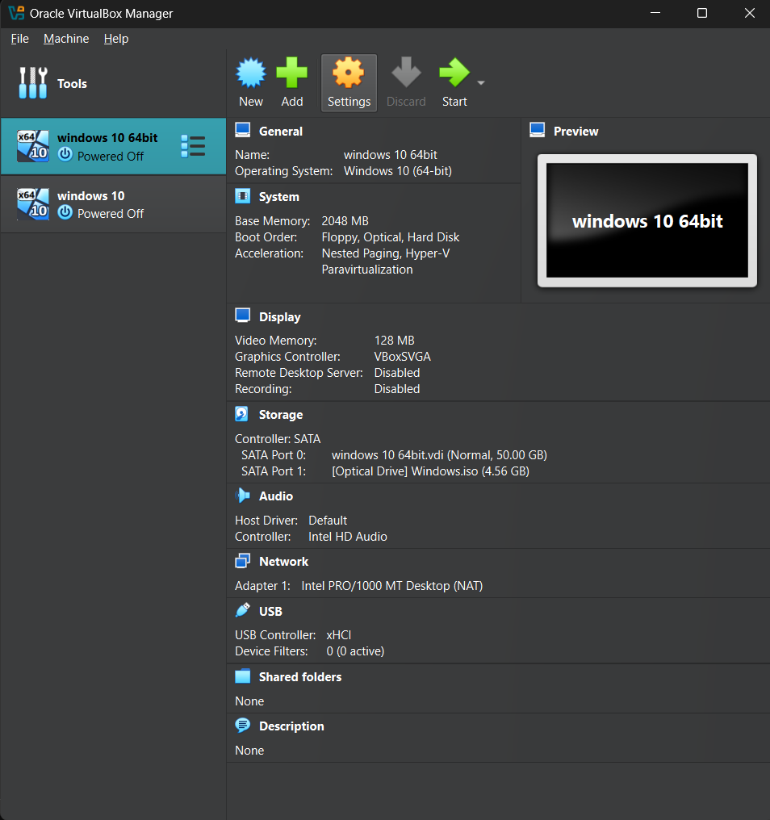

Step2:Click on the left side panel storage and select the Sata port 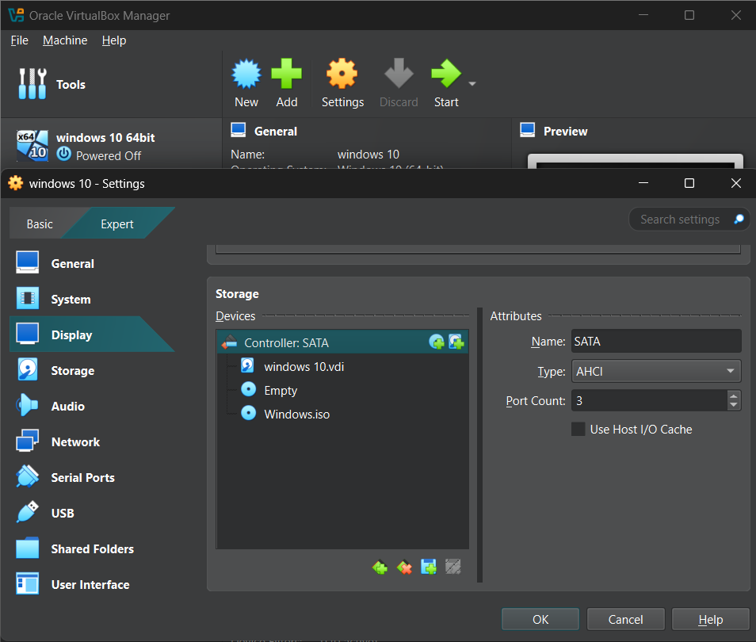

Step 3:Add The AHCI (SATA) Disk

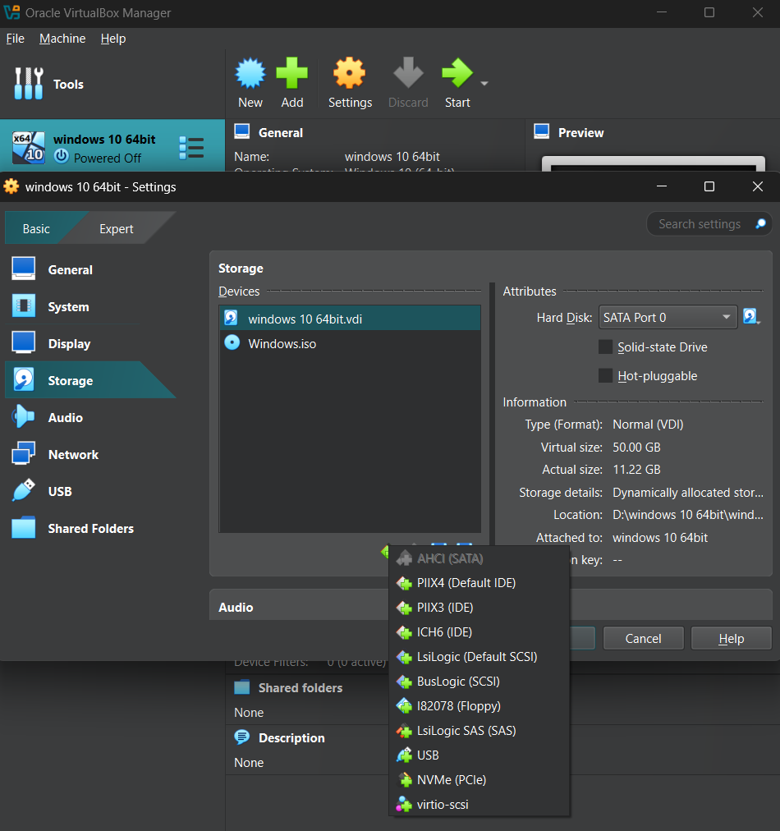

Step 4:Click on ok and return to home page.

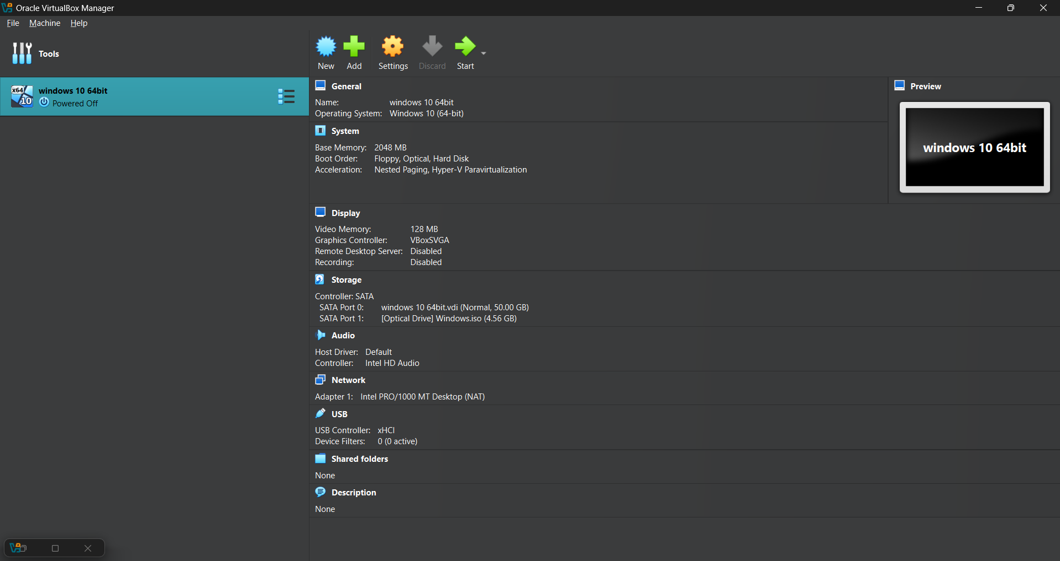

Step 5:Start the virtual machine

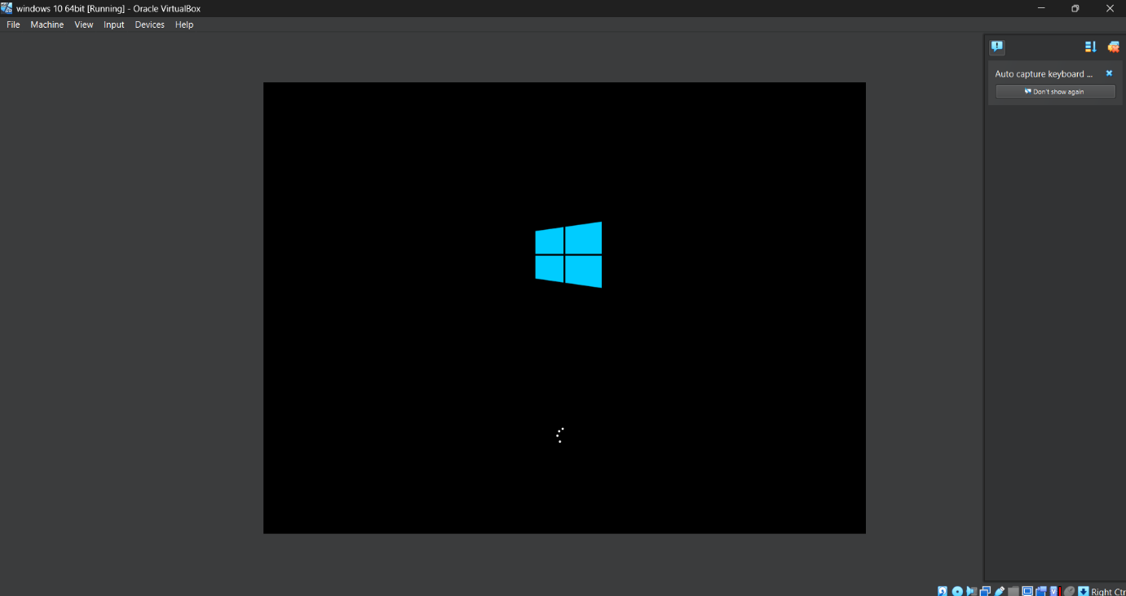

Step 6:

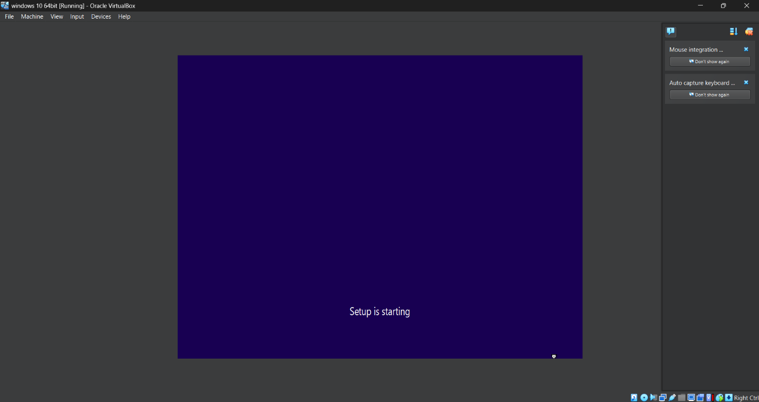

Step 7:

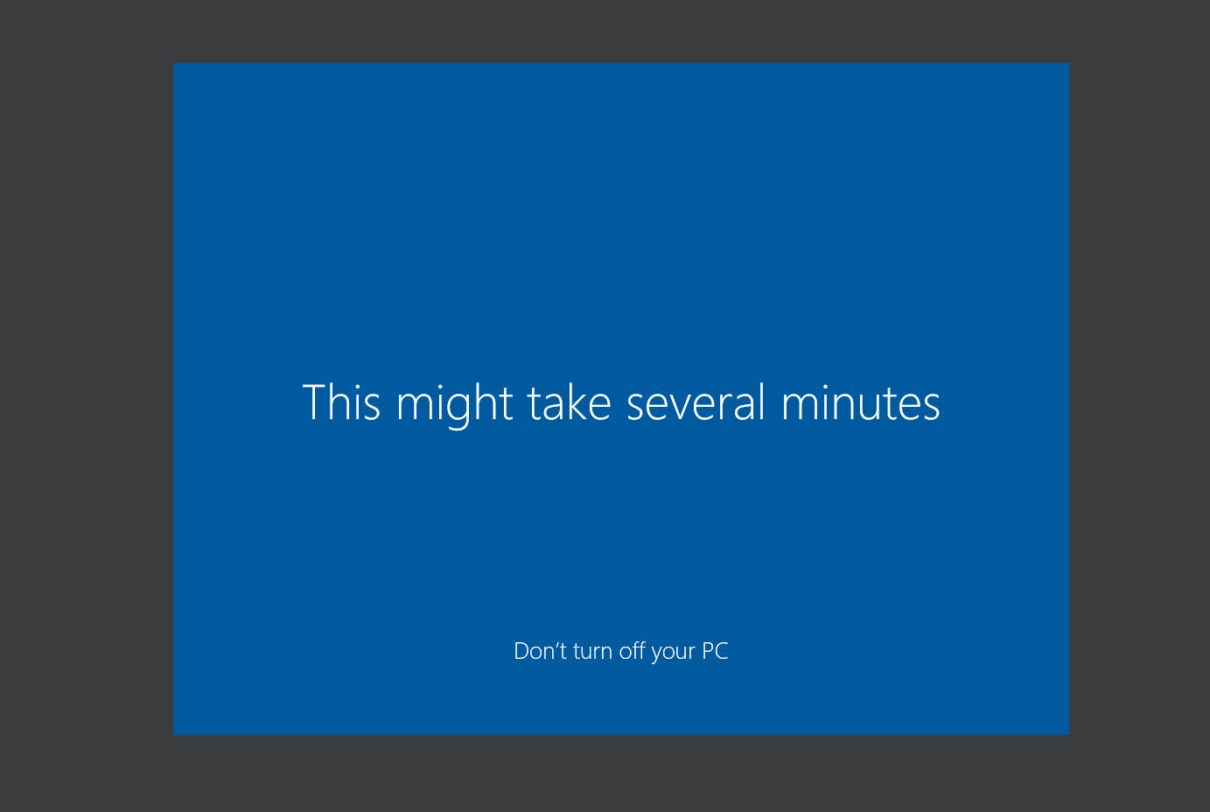

Step 8:

